Hexagonal Pyramid

Definition
# Source: AI Source: Provided by: [Data Path: Persons Table -> ID Column: 1, Name_En Column: Motasem Essam] -> From: [ChatGPT] on [7/25/2026]
A hexagonal pyramid is a three-dimensional geometric solid with one hexagonal base and six triangular lateral faces that meet at a common point called the apex.
A hexagonal pyramid has:
- 7 faces: 1 hexagonal base and 6 triangular lateral faces.
- 12 edges: 6 base edges and 6 lateral edges.
- 7 vertices: 6 vertices around the base and 1 apex.
A hexagonal pyramid can have a regular or irregular hexagonal base and may be right or oblique, depending on the position of its apex.
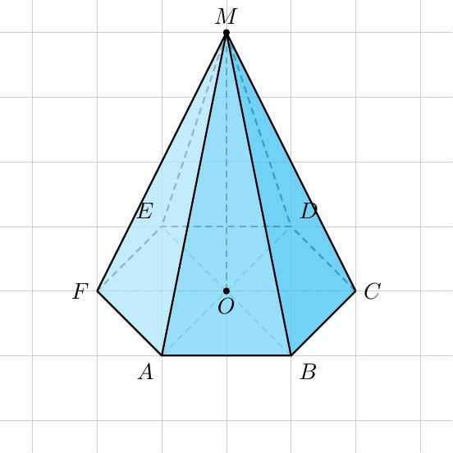
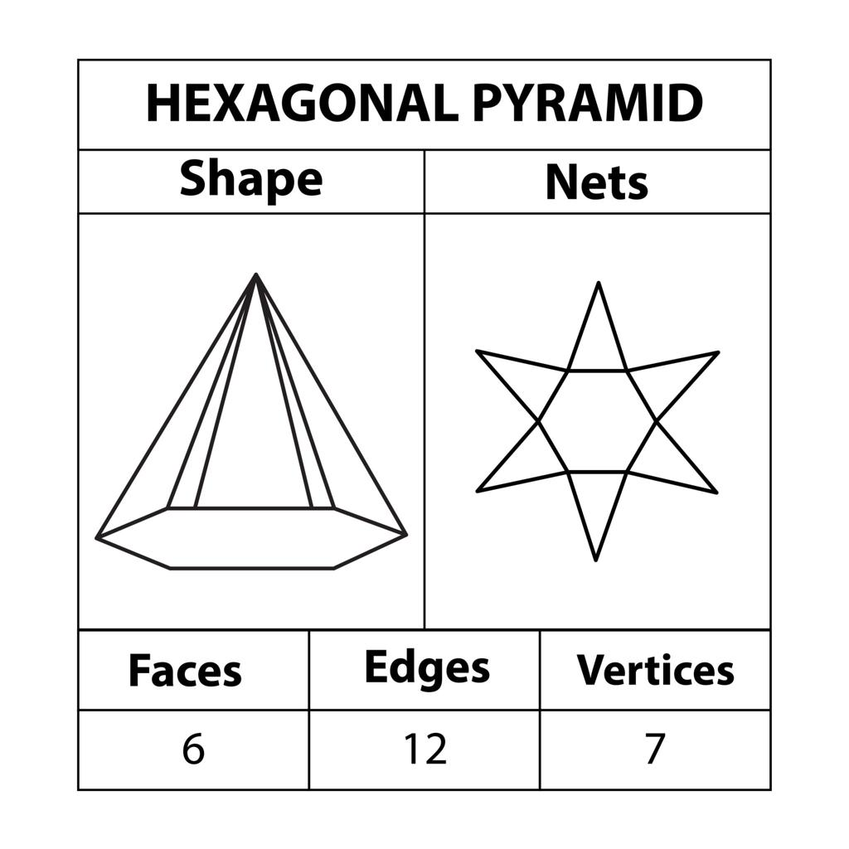
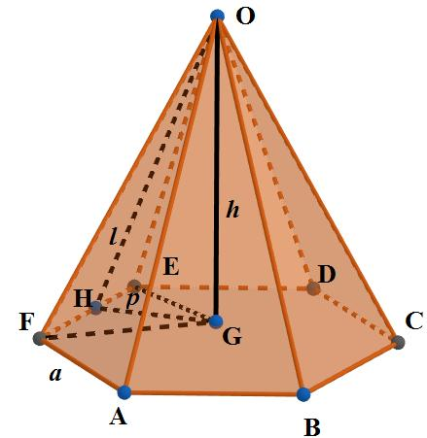

Simple Definition
# Source: AI Source: Provided by: [Data Path: Persons Table -> ID Column: 1, Name_En Column: Motasem Essam] -> From: [ChatGPT] on [7/25/2026]
A hexagonal pyramid is like a pyramid with a six-sided base. Each corner of the hexagon connects to the same apex, forming six triangular sides.

Classification Tree
# Source: AI Source: Provided by: [Data Path: Persons Table -> ID Column: 1, Name_En Column: Motasem Essam] -> From: [ChatGPT] on [7/25/2026]
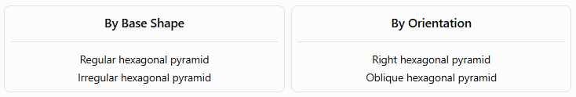
By Base Shape
Regular hexagonal pyramid
Irregular hexagonal pyramid
By Orientation
Right hexagonal pyramid
Oblique hexagonal pyramid
A. By Base Shape
- Regular hexagonal pyramid: The base is a regular hexagon, with six equal sides and six equal interior angles. In a regular pyramid, the apex is positioned above the base center, making the lateral faces congruent triangles.
- Irregular hexagonal pyramid: The base is an irregular hexagon, so its sides or interior angles are not all equal. Its lateral faces may differ in shape and size.
B. By Spatial Orientation
- Right hexagonal pyramid: The perpendicular from the apex meets the base at its center. For a regular base, this gives the usual upright, symmetrical pyramid.
- Oblique hexagonal pyramid: The apex is offset from the base center, so the lateral edges and triangular faces are generally unequal in length or size.

Key Characteristics
# Source: AI Source: Provided by: [Data Path: Persons Table -> ID Column: 1, Name_En Column: Motasem Essam] -> From: [ChatGPT] on [7/25/2026]
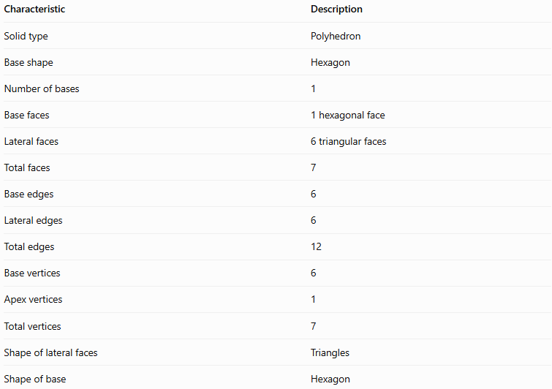
Characteristic | Description
Solid type | Polyhedron
Base shape | Hexagon
Number of bases | 1
Base faces | 1 hexagonal face
Lateral faces | 6 triangular faces
Total faces | 7
Base edges | 6
Lateral edges | 6
Total edges | 12
Base vertices | 6
Apex vertices | 1
Total vertices | 7
Shape of lateral faces | Triangles
Shape of base | Hexagon

Geometric Representation
# Source: AI Source: Provided by: [Data Path: Persons Table -> ID Column: 1, Name_En Column: Motasem Essam] -> From: [ChatGPT] on [7/25/2026]
Consider a hexagonal pyramid named ABCDEF–G, where ABCDEF is the hexagonal base and G is the apex.
Its components are:
- Base ABCDEF: The six-sided polygon at the bottom.
- Apex G: The vertex where all six lateral edges meet.
- Base edges: AB, BC, CD, DE, EF, and FA.
- Lateral edges: AG, BG, CG, DG, EG, and FG.
- Lateral faces: Triangles ABG, BCG, CDG, DEG, EFG, and FAG.
- Height $h$: The perpendicular distance from the apex to the plane containing the base.
- Slant height $l$: For a regular right hexagonal pyramid, the perpendicular distance from the apex to the midpoint of a base edge, measured along a lateral face.

Mathematical Representations and Formulas
# Source: AI Source: Provided by: [Data Path: Persons Table -> ID Column: 1, Name_En Column: Motasem Essam] -> From: [ChatGPT] on [7/25/2026]
Let:
- $B$ = area of the hexagonal base
- $p$ = perimeter of the base
- $a$ = side length of a regular hexagonal base
- $h$ = perpendicular height
- $l$ = slant height of a regular right hexagonal pyramid

A. Number of faces, edges, and vertices
# Source: AI Source: Provided by: [Data Path: Persons Table -> ID Column: 1, Name_En Column: Motasem Essam] -> From: [ChatGPT] on [7/25/2026]
For a pyramid with an $n$-sided base:
$$F=n+1, E=2n, V_{e}=n+1$$
For a hexagonal pyramid, $n=6$:
$$F=6+1=7$$
$$E=2\left(6\right)=12$$
$$V_{e}=6+1=7$$
Here, $V_{e}$ means the number of vertices, not the volume.

B. Base area
# Source: AI Source: Provided by: [Data Path: Persons Table -> ID Column: 1, Name_En Column: Motasem Essam] -> From: [ChatGPT] on [7/25/2026]
For a regular hexagon with side length $a$:
$$B=\frac{3\sqrt{3}}{2}a^{2}$$
The perimeter is:
$$p=6a$$
Alternatively, using the base apothem $r$:
$$B=\frac{1}{2}pr$$

C. Volume
# Source: AI Source: Provided by: [Data Path: Persons Table -> ID Column: 1, Name_En Column: Motasem Essam] -> From: [ChatGPT] on [7/25/2026]
The volume of any hexagonal pyramid is one-third the area of its base multiplied by its perpendicular height:
$$\boxed{V=\frac{1}{3}Bh}$$
For a regular hexagonal base:
$$\boxed{V=\frac{\sqrt{3}}{2}a^{2}h}$$

D. Lateral surface area
# Source: AI Source: Provided by: [Data Path: Persons Table -> ID Column: 1, Name_En Column: Motasem Essam] -> From: [ChatGPT] on [7/25/2026]
For any hexagonal pyramid, the lateral surface area is the sum of its six triangular face areas:
$$A_{L}=A_{1}+A_{2}+A_{3}+A_{4}+A_{5}+A_{6}$$
For a regular right hexagonal pyramid, all six lateral faces are congruent, so:
$$\boxed{A_{L}=\frac{1}{2}pl=3al}$$

E. Total surface area
# Source: AI Source: Provided by: [Data Path: Persons Table -> ID Column: 1, Name_En Column: Motasem Essam] -> From: [ChatGPT] on [7/25/2026]
The total surface area is the base area plus the lateral surface area:
$$\boxed{A_{T}=B+A_{L}}$$
For a regular right hexagonal pyramid:
$$\boxed{A_{T}=\frac{3\sqrt{3}}{2}a^{2}+3al}$$

F. Slant height relationship
# Source: AI Source: Provided by: [Data Path: Persons Table -> ID Column: 1, Name_En Column: Motasem Essam] -> From: [ChatGPT] on [7/25/2026]
For a regular right hexagonal pyramid, the base apothem is:
$$r=\frac{\sqrt{3}}{2}a$$
Using the perpendicular height $h$ and the base apothem:
$$\boxed{l=\sqrt{h^{2}+\frac{3}{4}a^{2}}}$$
This relationship applies to the regular right case, not to every irregular or oblique hexagonal pyramid.

Worked Examples
# Source: AI Source: Provided by: [Data Path: Persons Table -> ID Column: 1, Name_En Column: Motasem Essam] -> From: [ChatGPT] on [7/25/2026]
Example 1: Counting the geometric elements
Problem: Find the number of faces, edges, and vertices of a hexagonal pyramid.
Solution:
The base has six sides, so $n=6$.
$$F=6+1=7$$
$$E=2\left(6\right)=12$$
$$V_{e}=6+1=7$$
Answer: 7 faces, 12 edges, and 7 vertices.
Example 2: Calculating the volume
Problem: A hexagonal pyramid has a base area of $72{\text{ cm}}^{2}$ and a perpendicular height of $10\text{ cm}$. Find its volume.
Solution:
$$V=\frac{1}{3}Bh$$
$$V=\frac{1}{3}\left(72\right)\left(10\right)$$
$$\boxed{V=240{\text{ cm}}^{3}}$$
Example 3: Finding the base area
Problem: A regular hexagonal pyramid has a base side length of $4\text{ cm}$. Find the base area.
Solution:
$$B=\frac{3\sqrt{3}}{2}a^{2}$$
$$B=\frac{3\sqrt{3}}{2}{\left(4\right)}^{2}=24\sqrt{3}$$
$$\boxed{B≈41.57{\text{ cm}}^{2}}$$
Example 4: Calculating lateral surface area
Problem: A regular right hexagonal pyramid has a base side length of $5\text{ cm}$ and a slant height of $8\text{ cm}$. Find its lateral surface area.
Solution:
First, calculate the perimeter:
$$p=6\left(5\right)=30\text{ cm}$$
Then calculate the lateral surface area:
$$A_{L}=\frac{1}{2}pl$$
$$A_{L}=\frac{1}{2}\left(30\right)\left(8\right)$$
$$\boxed{A_{L}=120{\text{ cm}}^{2}}$$
Example 5: Verifying Euler's formula
For a convex hexagonal pyramid:
$$V_{e}-E+F=2$$
Substitute the counts:
$$7-12+7=2$$
Therefore, the pyramid satisfies Euler's formula for convex polyhedra.

Comparison with Related Geometric Solids
# Source: AI Source: Provided by: [Data Path: Persons Table -> ID Column: 1, Name_En Column: Motasem Essam] -> From: [ChatGPT] on [7/25/2026]
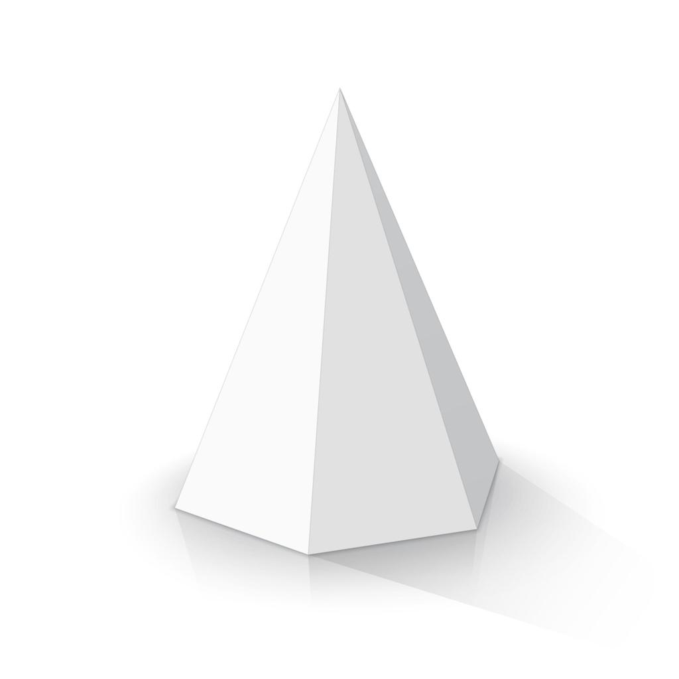
Hexagonal Pyramid
- One hexagonal base.
- Six triangular lateral faces.
- 7 faces, 12 edges, 7 vertices.
- Volume: $\frac{1}{3}Bh$.
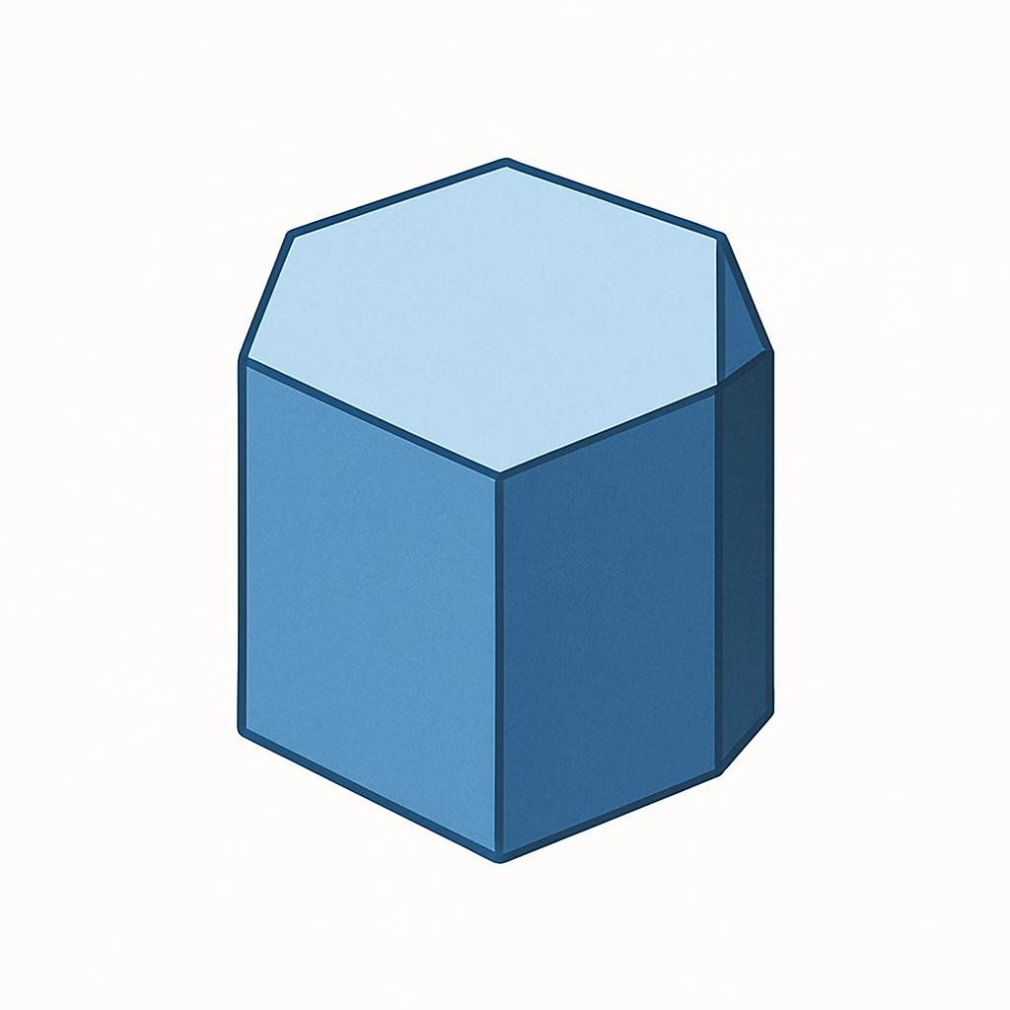
Hexagonal Prism
- Two hexagonal bases.
- Six parallelogram lateral faces; rectangles in a right prism.
- 8 faces, 18 edges, 12 vertices.
- Volume: $Bh$.
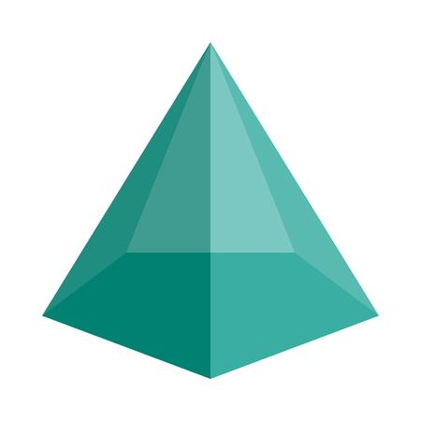
Pentagonal Pyramid
- One pentagonal base.
- Five triangular lateral faces.
- 6 faces, 10 edges, 6 vertices.
- Volume: $\frac{1}{3}Bh$.

Constructing Hexagonal Pyramid in Solid Geometry

Instruments Used
# Source: AI Source: Provided by: [Data Path: Persons Table -> ID Column: 1, Name_En Column: Motasem Essam] -> From: [ChatGPT] on [7/25/2026]
The construction uses physical geometric drawing instruments rather than coordinate-based methods.
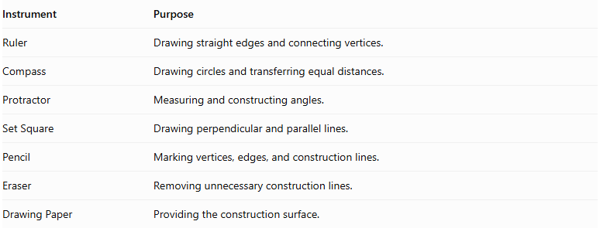
Instrument | Purpose
Ruler | Drawing straight edges and connecting vertices.
Compass | Drawing circles and transferring equal distances.
Protractor | Measuring and constructing angles.
Set Square | Drawing perpendicular and parallel lines.
Pencil | Marking vertices, edges, and construction lines.
Eraser | Removing unnecessary construction lines.
Drawing Paper | Providing the construction surface.

Construction Procedures

Base-Based Construction
# Source: AI Source: Provided by: [Data Path: Persons Table -> ID Column: 1, Name_En Column: Motasem Essam] -> From: [ChatGPT] on [7/25/2026]
- Draw a hexagonal base using a ruler, compass, and protractor.
- Identify and mark its six vertices.
- Determine the position of the apex above or away from the base.
- Connect the apex to each of the six base vertices.
- Complete the six triangular lateral faces.
- Darken the visible edges and use dashed lines for hidden edges.

Apex-Based Construction
# Source: AI Source: Provided by: [Data Path: Persons Table -> ID Column: 1, Name_En Column: Motasem Essam] -> From: [ChatGPT] on [7/25/2026]
- Mark the intended apex position.
- Draw the hexagonal base beneath the apex.
- Identify the six base vertices.
- Connect each base vertex to the apex.
- Complete the lateral triangular faces.

Vertex-Connection Construction
# Source: AI Source: Provided by: [Data Path: Persons Table -> ID Column: 1, Name_En Column: Motasem Essam] -> From: [ChatGPT] on [7/25/2026]
- Construct the six vertices of the hexagonal base.
- Mark the apex as the seventh vertex.
- Connect the apex to all six base vertices.
- Connect consecutive base vertices to complete the hexagonal base.
- Check that all edges and faces form a closed solid.

Edge-Based Construction
# Source: AI Source: Provided by: [Data Path: Persons Table -> ID Column: 1, Name_En Column: Motasem Essam] -> From: [ChatGPT] on [7/25/2026]
- Draw the six edges of the hexagonal base.
- Determine the six lateral edges extending from the base vertices to the apex.
- Construct and connect the lateral edges.
- Complete the triangular lateral faces.

Face-Based Construction
# Source: AI Source: Provided by: [Data Path: Persons Table -> ID Column: 1, Name_En Column: Motasem Essam] -> From: [ChatGPT] on [7/25/2026]
- Construct the hexagonal base.
- Draw six triangular faces around the base.
- Connect the corresponding vertices and edges.
- Ensure that all six triangular faces meet at the apex.

Net-Based Construction
# Source: AI Source: Provided by: [Data Path: Persons Table -> ID Column: 1, Name_En Column: Motasem Essam] -> From: [ChatGPT] on [7/25/2026]
- Draw one hexagonal base.
- Construct six triangular faces around the hexagon.
- Add tabs if necessary for physical assembly.
- Cut out the net.
- Fold the triangular faces upward.
- Join their edges to form the hexagonal pyramid.
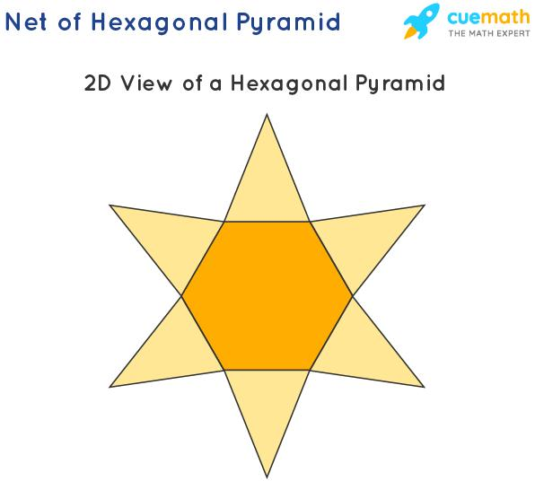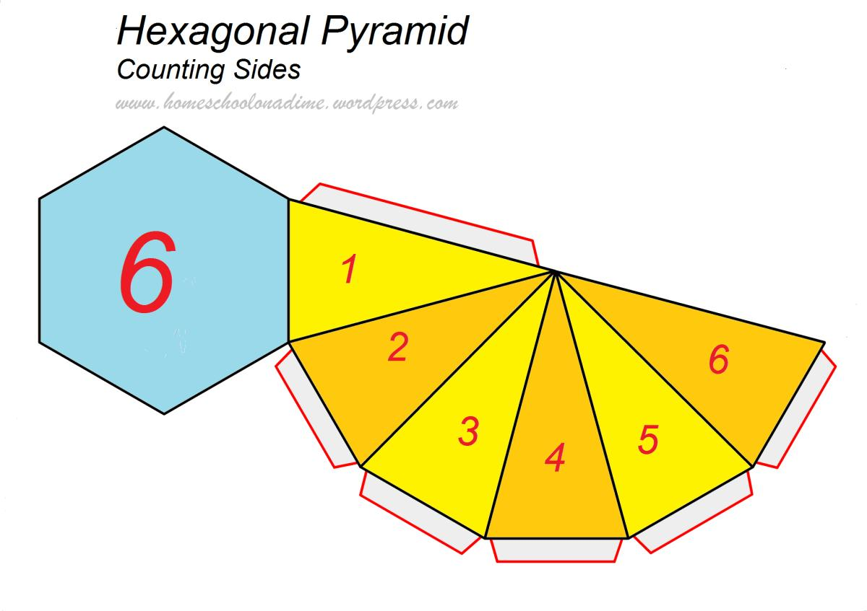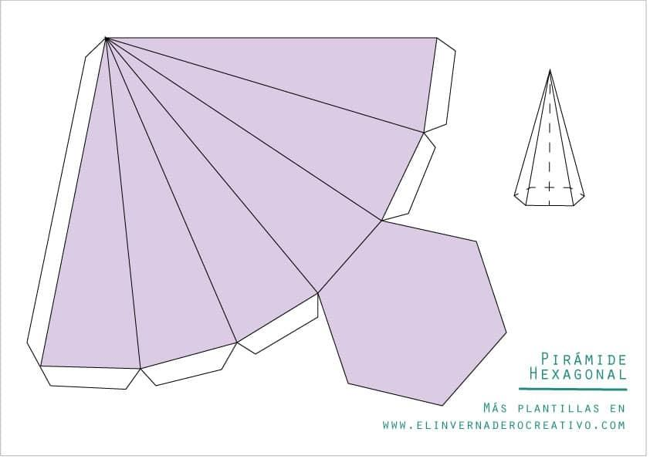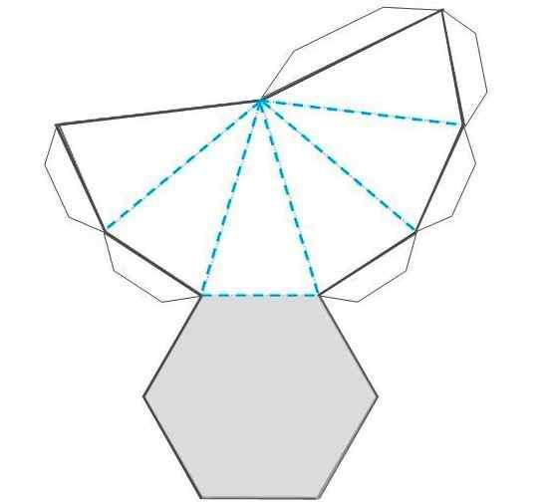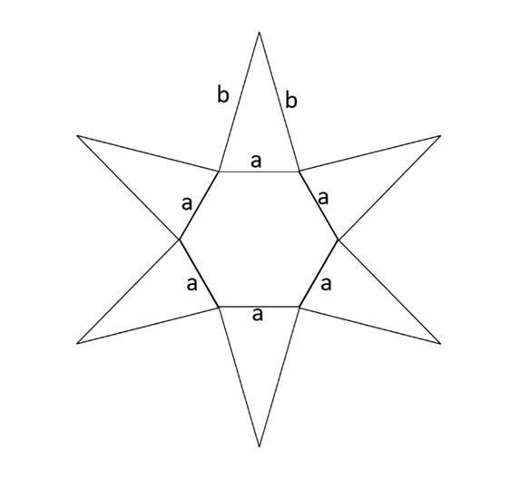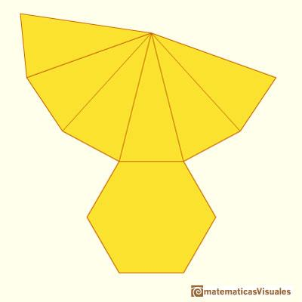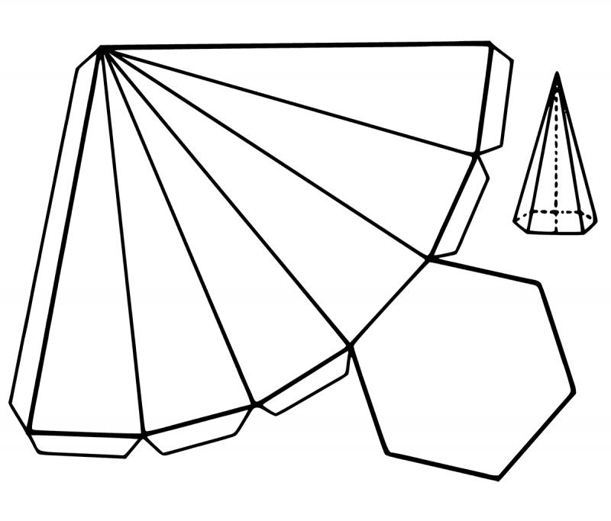

Applications
# Source: AI Source: Provided by: [Data Path: Persons Table -> ID Column: 1, Name_En Column: Motasem Essam] -> From: [ChatGPT] on [7/25/2026]
Hexagonal pyramids are useful in:
- Architecture: Designing decorative roof forms and pyramid-like structures with hexagonal footprints.
- Engineering and 3D modeling: Representing and constructing polygon-based solids.
- Mathematics education: Studying polyhedra, vertices, edges, faces, surface area, and volume.
- Computer graphics: Building 3D meshes using a hexagonal base and a common apex.
- Packaging and product design: Developing decorative containers and geometric models.

Key Points
# Source: AI Source: Provided by: [Data Path: Persons Table -> ID Column: 1, Name_En Column: Motasem Essam] -> From: [ChatGPT] on [7/25/2026]
- A hexagonal pyramid has exactly one hexagonal base.
- Its six lateral faces are triangles.
- It has 7 faces, 12 edges, and 7 vertices.
- Its volume is one-third the base area multiplied by the perpendicular height.
- The formula $A_{L}=\frac{1}{2}pl$ applies to a regular right hexagonal pyramid when $l$ is its face slant height.
- A regular hexagonal pyramid has a regular hexagonal base; a right regular pyramid also has its apex directly above the base center.
- Euler's formula is satisfied: $V_{e}-E+F=2$.

Conclusion
# Source: AI Source: Provided by: [Data Path: Persons Table -> ID Column: 1, Name_En Column: Motasem Essam] -> From: [ChatGPT] on [7/25/2026]
A hexagonal pyramid is a polyhedron formed by connecting the six vertices of a hexagonal base to a single apex. Its structure consists of seven faces, twelve edges, and seven vertices. Understanding its base, lateral faces, height, and slant height makes it possible to classify the solid and calculate its volume and surface area. It also provides a useful example for studying the geometric properties shared by pyramids with polygonal bases.

